CHAPTER FIVE
SUMMARY, CONCLUSION AND RECOMMENDATIONS
5.1 Introduction
This chapter presents the summary, conclusion, contributions, recommendations, further research directions, and limitations of the study. The chapter reflects on the extent to which the objectives of the study were achieved through the analysis, design, implementation, and testing of the proposed School Learning Management System (LMS). It also highlights the contribution of the developed system to the management of academic activities and identifies areas for future improvement.
5.2 Summary of the Study
The study focused on the design and implementation of a web-based School Learning Management System for educational institutions. The study was motivated by challenges identified in traditional and fragmented academic management practices, including difficulties in managing student and course information, delays in assignment submission and grading, limited access to learning materials, poor communication among stakeholders, difficulties in generating academic reports, inadequate centralisation of educational records, and dependence on physical processes for academic activities.
The analysis of the existing system revealed that academic information was often managed through paper-based records, spreadsheets, separate applications, and disconnected communication channels. These practices resulted in duplication of information, delays, increased possibility of errors, difficulty retrieving records, and inefficient coordination among administrators, teachers, and students.
Based on the identified challenges, a web-based Learning Management System was designed to centralise major academic activities within a single platform. The proposed system provides role-based functionality for three main categories of users: administrators, teachers, and students.
The administrator functions include user management, department and programme management, course management, academic session management, reporting, system settings, and monitoring of academic activities. Teachers are provided with facilities for managing courses, uploading learning materials, creating assignments and assessments, grading student work, recording attendance, monitoring student performance, and communicating with students. Students can access enrolled courses and learning materials, submit assignments, participate in assessments, view grades, and receive academic notifications.
The system adopts an API-first architecture in which the frontend communicates with a PHP-based RESTful API. The backend processes requests, applies authentication and authorisation, performs business logic, interacts with the MySQL database, and returns responses in JSON format. This architecture separates the presentation layer from the application and data layers and provides a foundation for future system extension.
The system was implemented using HTML5, CSS3, JavaScript, PHP, MySQL, RESTful API technologies, JSON, and related development tools. The implementation was subsequently subjected to functional, security and access-control, API, and database testing. The test cases documented in Chapter Four covered major system operations, including authentication, role-based access, academic management, assessments, communication, API requests, and database retrieval.
The results demonstrate that the developed system provides a centralised platform for managing several academic and administrative activities and addresses a number of the weaknesses identified in the existing system.
5.3 Achievement of Objectives
The study was guided by seven specific objectives. The achievement of each objective is discussed below.
5.3.1 Objective One: To analyse the challenges associated with traditional academic management systems
This objective was achieved through the analysis of the existing academic management processes. The analysis identified several challenges, including inefficient record management, fragmented information systems, manual attendance recording, delays in assignment processing and feedback, poor communication among stakeholders, difficulty generating academic reports, and inadequate centralisation of academic information.
The existing workflow analysis provided the basis for identifying the functional and non-functional requirements of the proposed Learning Management System. The identified problems demonstrated the need for a centralised platform capable of automating and integrating major academic activities.
5.3.2 Objective Two: To design a user-friendly Learning Management System for educational institutions
This objective was achieved through the design of the proposed School Learning Management System. The system design incorporated a role-based workflow and separate functionality for administrators, teachers, and students.
The design included the system workflow, system architecture, use case model, Data Flow Diagram, database design, API architecture, input design, output design, and user interface design. The proposed interface was designed to provide users with access to functions relevant to their responsibilities while maintaining a simple and responsive interaction environment.
The design therefore provided a structured foundation for the implementation of the system.
5.3.3 Objective Three: To develop a platform for managing students, teachers, courses, and academic records
This objective was addressed through the implementation of the user management, academic management, course management, enrolment, attendance, results, and reporting functionality.
The developed system provides administrators with facilities for managing users, departments, courses, academic sessions, and other institutional information. Teachers can manage course-related activities and student academic information, while students can access their academic information through the student interface.
The centralised database and RESTful API architecture provide a common platform through which academic information can be stored, retrieved, and processed.
5.3.4 Objective Four: To provide facilities for uploading and accessing learning materials online
This objective was achieved through the Learning Materials Module. Teachers can upload learning resources associated with courses, while students can access the available materials through the system.
The implementation reduces dependence on physical distribution of learning resources and provides students with a centralised location from which course materials can be accessed. This addresses the problem identified in the existing system where access to learning resources could be restricted by physical presence or fragmented distribution channels.
5.3.5 Objective Five: To enable assignment creation, submission, and grading electronically
This objective was achieved through the Assignment Management and Assessment functionality.
Teachers can create assignments and manage student submissions, while students can submit their work through the system. The assessment functionality also provides mechanisms for grading and displaying academic results.
The testing results documented in Chapter Four include assignment, assessment, grading, and result-related test cases. The successful execution of these tests demonstrates that the implemented system supports the major electronic assignment and assessment processes defined by the study.
5.3.6 Objective Six: To facilitate communication between students, teachers, and administrators
This objective was addressed through the Communication and Notification functionality of the system.
The developed system provides facilities for publishing announcements and displaying notifications to users. This provides a centralised communication mechanism for distributing academic information and reduces dependence on disconnected channels such as printed notices and separate messaging platforms.
The testing documented in Chapter Four includes announcement creation, notification viewing, and notification status operations. These results provide evidence that the implemented communication and notification functions support the intended academic communication processes.
5.3.7 Objective Seven: To improve the efficiency and effectiveness of educational administration
The objective was addressed by integrating major academic and administrative activities into a single web-based platform.
The system reduces the need for repeated manual handling of academic information by providing centralised user, course, learning material, assignment, assessment, attendance, communication, and reporting functions. The RESTful API architecture also provides a structured mechanism for communication between the frontend and backend components.
The testing results presented in Chapter Four indicate that the tested system functions performed according to their expected behaviour. However, the study did not conduct large-scale institutional performance testing; therefore, claims concerning efficiency should be understood in relation to the implemented functionality and testing scope rather than as a measured comparison of institutional productivity.
5.4 Conclusion
The study concludes that a web-based School Learning Management System can provide an integrated platform for addressing several challenges associated with traditional and fragmented academic management processes.
The developed system brings together important academic activities including user management, course management, learning material distribution, assignment submission, assessment, attendance, results, communication, notifications, and reporting. These functions provide administrators, teachers, and students with a centralised environment for accessing and managing academic information.
The implementation of role-based access mechanisms provides different users with access to functions according to their assigned responsibilities. The API-first architecture separates the frontend from the backend services and database operations, providing a structured foundation for maintenance and future extension.
The MySQL relational database provides the central storage mechanism for academic and administrative information, while the RESTful API enables communication between the frontend and backend through HTTP requests and JSON responses.
The testing conducted on the developed system covered major functional areas, security and access-control operations, API requests, and database interactions. The documented test results indicate that the tested functions produced the expected outcomes.
Although the study was subject to limitations such as time, financial resources, internet dependence, and limited testing within selected educational environments, the developed system provides a practical foundation for improving the management and delivery of academic services.
The study therefore concludes that the proposed School Learning Management System addresses the major problems identified during the analysis of the existing system and provides an integrated platform capable of supporting academic administration, teaching, learning, assessment, communication, and access to educational information.
5.5 Contributions of the Study
The study makes contributions in the areas of academic management, educational technology, and software development.
5.5.1 Academic Contribution
The study provides a structured approach to analysing and addressing challenges associated with traditional academic management processes. It demonstrates how academic activities can be modelled and integrated into a centralised information system.
The study also provides a reference for future research involving web-based Learning Management Systems and educational information systems.
5.5.2 Practical Contribution
The developed system provides educational institutions with a centralised platform for managing academic activities.
The system contributes to:
- Improved access to academic information.
- Centralised management of learning materials.
- Electronic assignment submission and grading.
- Centralised attendance and academic records.
- Improved communication through announcements and notifications.
- Easier access to academic reports.
- Reduced dependence on paper-based academic processes.
- Improved coordination between administrators, teachers, and students.
5.5.3 Technical Contribution
The study demonstrates the application of an API-first architecture in the development of a School Learning Management System.
The separation between the frontend, RESTful API, business logic, and MySQL database provides a structured software architecture that can support future enhancement and integration with other client applications.
The project also demonstrates the use of HTML5, CSS3, JavaScript, PHP, MySQL, REST APIs, JSON, and Fetch API technologies in developing an integrated web-based academic management platform.
5.6 Recommendations
Based on the findings, implementation, and testing of the developed system, the following recommendations are made.
5.6.1 Recommendations for Educational Institutions
Educational institutions should consider adopting integrated Learning Management Systems to centralise academic information and reduce dependence on paper-based and fragmented academic management processes.
Institutions should also provide adequate training for administrators, teachers, and students to ensure that users can effectively utilise the available system functions.
Appropriate server infrastructure, network connectivity, storage capacity, and backup procedures should be provided to support reliable operation of the system.
5.6.2 Recommendations for System Administrators
System administrators should regularly review user accounts and access permissions to ensure that users retain only the privileges required for their responsibilities.
Regular database backups should be maintained to reduce the risk of academic data loss. System software and dependencies should also be updated regularly to address security and compatibility issues.
Administrators should monitor system performance and storage usage as the volume of academic records and uploaded learning materials increases.
5.6.3 Recommendations for Teachers
Teachers should make effective use of the learning material, assignment, assessment, attendance, communication, and grading functions provided by the system.
Learning materials and academic information should be updated regularly to ensure that students have access to current and relevant resources.
Teachers should also use the electronic assessment and grading facilities consistently to improve the organisation and accessibility of student academic information.
5.6.4 Recommendations for Students
Students should use the system regularly to access learning materials, submit assignments, participate in assessments, monitor grades, and receive academic announcements.
Students should also comply with institutional policies concerning responsible use of digital learning resources and protect their account credentials from unauthorised access.
5.7 Suggestions for Further Research
Although the developed system addresses the major objectives of the study, several areas can be explored in future research.
5.7.1 Mobile Application Development
Future researchers may develop dedicated Android and iOS applications that communicate with the existing RESTful API. This would provide students and teachers with additional access to academic services through mobile devices.
5.7.2 Artificial Intelligence Integration
Future versions of the system may incorporate artificial intelligence features such as intelligent tutoring, automated assessment support, learning analytics, and predictive student performance analysis.
5.7.3 Advanced Learning Analytics
Future research may develop advanced dashboards for analysing student engagement, attendance, assessment performance, and learning progress.
5.7.4 Virtual Learning Integration
Integration with video conferencing and virtual classroom platforms could extend the system's capabilities for institutions that support online and blended learning.
5.7.5 Biometric Attendance
Future studies may investigate biometric technologies such as fingerprint or facial recognition for automated attendance management, subject to institutional requirements and applicable privacy considerations.
5.7.6 Cloud Deployment
Future researchers may investigate cloud deployment to improve system accessibility, infrastructure flexibility, and capacity for handling increased usage.
5.7.7 Multi-Institution Support
The system could be extended to support multiple schools or educational institutions through a multi-tenant architecture, allowing institutions to manage their academic activities independently within a shared platform.
5.8 Limitations of the Study
The study encountered several limitations that should be considered when interpreting the results.
First, the project was subject to time constraints associated with the development and documentation period. These constraints limited the extent to which additional features and broader evaluations could be conducted.
Second, financial limitations affected the availability of advanced infrastructure and resources for large-scale deployment and testing.
Third, the system is web-based and therefore depends on reliable internet connectivity for remote access. Poor or unstable connectivity may affect activities such as login, file uploads, assignment submission, and access to learning materials.
Fourth, testing was conducted within a limited educational environment. Consequently, the results should not be interpreted as a comprehensive evaluation across all types and sizes of educational institutions.
Finally, the system may require additional infrastructure and optimisation if deployed with substantially larger numbers of users, academic records, and uploaded learning resources.
5.9 Contribution of the System
The developed Ghana Senior High School Learning Management System (GSLMS) contributes to the improvement of teaching, learning, academic administration, and communication within Senior High Schools. The system provides an integrated digital platform that brings together activities that are traditionally performed through separate manual processes.
One major contribution of the system is the centralisation of academic information. The system provides a common platform for managing students, teachers, courses, learning materials, assessments, grades, attendance, timetables, announcements, and other academic activities. This reduces the dependence on paper-based records and disconnected information systems.
The system also contributes to improved access to learning resources. Teachers can upload and manage course materials, assignments, quizzes, and other resources, while students can access relevant learning materials through the platform. This supports learning beyond the physical classroom and allows students to revisit materials when necessary.
Another important contribution is the digitisation of assessment and grading processes. The system provides functionality for managing assessments, recording scores, calculating academic results, and presenting relevant information to authorised users. This can reduce errors associated with manual calculations and make academic records easier to retrieve.
The system also improves communication among educational stakeholders. Through announcements, notifications, and messaging functionality, administrators, teachers, students, and parents can receive and exchange relevant information. This creates a more connected learning environment and can improve the flow of information within the school.
Furthermore, the system provides role-based access control. Different users are provided with access according to their responsibilities. Administrators can manage institutional and user information, teachers can manage teaching and assessment activities, students can access learning resources and academic information, and parents can monitor relevant information concerning their wards.
The system also contributes to academic monitoring and decision-making through reports and analytics. School administrators and authorised users can obtain information about academic activities, attendance, assessments, and other aspects of the learning process. Such information can support the identification of areas requiring attention and facilitate more informed decisions.
From a technical perspective, the project demonstrates the application of web-based software engineering principles in developing an educational information system. The separation of the frontend from the PHP-based API backend provides a structured architecture that can support future expansion and integration with other applications.
Overall, the system contributes to the digital transformation of Senior High School education by providing a centralised, accessible, and structured platform for managing learning and academic activities.
5.10 Future Enhancements
Although the developed system provides a wide range of functionality, several enhancements can be implemented in future versions to increase its effectiveness, scalability, accessibility, and usefulness.
5.10.1 Mobile Application
A dedicated Android and iOS mobile application could be developed to complement the web-based system. The application would allow students, teachers, parents, and administrators to access important services from mobile devices. Push notifications could also be incorporated to provide users with immediate updates about assignments, announcements, grades, and other academic activities.
5.10.2 Artificial Intelligence Integration
Future versions could incorporate Artificial Intelligence (AI) to provide intelligent educational services. For example, AI could analyse student performance and identify students who may require additional academic support. An AI-powered learning assistant could also help students find relevant learning resources and provide explanations for selected topics.
5.10.3 Online and Live Classes
The system could be enhanced with integrated virtual classroom functionality. Video conferencing, live lessons, screen sharing, chat, and recorded lessons could be incorporated to support remote and blended learning.
5.10.4 Advanced Learning Analytics
More advanced analytics could be introduced to analyse student performance over time. The system could generate performance trends, identify weak subject areas, compare assessment results, and provide early-warning indicators for students who are experiencing academic difficulties.
5.10.5 Offline Learning Support
Since reliable Internet connectivity may not always be available to all students, future versions could provide offline access to selected learning materials. Materials could be downloaded while Internet access is available and accessed later without an active connection.
5.10.6 SMS and Email Integration
The notification system could be expanded to support SMS and email communication. This would allow parents and students to receive important notifications even when they are not actively logged into the platform.
5.10.7 Online Examination Module
A comprehensive online examination module could be implemented to support timed examinations, automatic submission, randomised questions, question banks, automatic marking, examination reports, and enhanced examination security.
5.10.8 Improved Security
Future versions should continuously strengthen security through mechanisms such as multi-factor authentication, improved password policies, enhanced session management, security monitoring, rate limiting, encrypted sensitive information, and regular security audits.
5.10.9 Cloud Deployment and Scalability
The system could be deployed on a reliable cloud infrastructure to support multiple Senior High Schools simultaneously. A multi-school architecture would allow institutions to operate independently while using the same underlying platform.
5.10.10 Parent and Guardian Engagement
Additional parent-oriented features could be introduced, including detailed academic progress reports, attendance alerts, assignment notifications, teacher-parent communication, and notifications concerning important school activities.
5.10.11 Integration with External Educational Systems
The system could eventually integrate with other educational platforms and services. Such integrations could facilitate data exchange and reduce duplicate data entry between the LMS and other school information systems.
5.10.12 Automated Backup and Disaster Recovery
Automated database backups, file backups, backup verification, and disaster recovery procedures could be implemented to minimise the risk of permanent data loss resulting from hardware failure, human error, security incidents, or other unexpected events.
5.11 Final Remark
The School Learning Management System developed in this study provides a centralised web-based platform for managing important academic and administrative activities. The system addresses several weaknesses identified in the existing academic management process by integrating user management, courses, learning materials, assignments, assessments, attendance, results, communication, notifications, and reporting within one platform.
The implementation and testing presented in Chapter Four demonstrate that the developed system can perform the major functions for which it was designed. The system therefore provides a practical foundation for improving academic information management and supporting teaching and learning activities.
However, the system should be regarded as a developed academic software solution whose wider institutional deployment would require further testing, user training, infrastructure provision, security review, maintenance, and possible integration with additional educational technologies.
Future improvements can build upon the existing API-first architecture to introduce mobile applications, advanced learning analytics, artificial intelligence, cloud deployment, and other technologies that can further enhance the delivery and management of educational services.

REFERENCES
Adzobu, F. K. (2014). Designing a multimedia learning environment to facilitate learning of fractions at the primary school level in Ghana. International Journal of Educational Research and Development, 3(1), 1–10.
Al-Fraihat, D., Joy, M., Masa’deh, R., & Sinclair, J. (2020). Evaluating e-learning systems success: An empirical study. Computers in Human Behavior, 102, 67–86. https://doi.org/10.1016/j.chb.2019.08.004
Bates, A. W. (2019). Teaching in a digital age: Guidelines for designing teaching and learning (2nd ed.). Tony Bates Associates Ltd.
Bass, J. M., & Heeks, R. (2011). Small and medium enterprise systems adoption in developing countries: Learning from a case study in Ghana. Information Technology for Development, 17(2), 1–17.
Bates, A. W. (2015). Teaching in a digital age: Guidelines for designing teaching and learning. Tony Bates Associates Ltd.
Beck, K., Beedle, M., van Bennekum, A., Cockburn, A., Cunningham, W., Fowler, M., Grenning, J., Highsmith, J., Hunt, A., Jeffries, R., Kern, J., Marick, B., Martin, R. C., Mellor, S., Schwaber, K., Sutherland, J., & Thomas, D. (2001). Manifesto for agile software development. Agile Alliance. https://agilemanifesto.org/
Connolly, T., & Begg, C. (2015). Database systems: A practical approach to design, implementation, and management (6th ed.). Pearson.
Creswell, J. W., & Creswell, J. D. (2018). Research design: Qualitative, quantitative, and mixed methods approaches (5th ed.). SAGE Publications.
Dabbagh, N., & Kitsantas, A. (2012). Personal learning environments, social media, and self-regulated learning: A natural formula for connecting formal and informal learning. The Internet and Higher Education, 15(1), 3–8. https://doi.org/10.1016/j.iheduc.2011.06.002
Davis, F. D. (1989). Perceived usefulness, perceived ease of use, and user acceptance of information technology. MIS Quarterly, 13(3), 319–340. https://doi.org/10.2307/249008
Food and Agriculture Organization of the United Nations. (2022). Digital learning for agriculture. FAO.
Garrison, D. R., Anderson, T., & Archer, W. (2000). Critical inquiry in a text-based environment: Computer conferencing in higher education. The Internet and Higher Education, 2(2–3), 87–105. https://doi.org/10.1016/S1096-7516(00)00016-6
International Organization for Standardization. (2018). ISO/IEC 25010:2011 systems and software engineering—Systems and software quality requirements and evaluation (SQuaRE)—System and software quality models. ISO.
International Telecommunication Union. (2023). Measuring digital development: Facts and figures 2023. International Telecommunication Union.
Laudon, K. C., & Laudon, J. P. (2022). Management information systems: Managing the digital firm (17th ed.). Pearson.
Moodle. (2024). Moodle documentation. Moodle. https://docs.moodle.org/
Mozilla Developer Network. (2024). MDN Web Docs. Mozilla. https://developer.mozilla.org/
Nielsen, J. (1994). Usability engineering. Morgan Kaufmann.
Organisation for Economic Co-operation and Development. (2021). Digital education outlook 2021: Pushing the frontiers with AI, blockchain and robots. OECD Publishing. https://doi.org/10.1787/589b283f-en
Pressman, R. S., & Maxim, B. R. (2020). Software engineering: A practitioner's approach (9th ed.). McGraw-Hill Education.
Sommerville, I. (2016). Software engineering (10th ed.). Pearson.
W3C. (2023). HTML: The living standard. World Wide Web Consortium. https://html.spec.whatwg.org/
W3C. (2023). Cascading Style Sheets (CSS). World Wide Web Consortium. https://www.w3.org/Style/CSS/
World Bank. (2020). Remote learning during COVID-19: Lessons from today's education technology. World Bank.
World Wide Web Consortium. (2024). Web standards. https://www.w3.org/standards/
Technical References
Apache Software Foundation. (2024). Apache HTTP Server documentation. https://httpd.apache.org/docs/
MySQL. (2024). MySQL 8.0 reference manual. Oracle Corporation. https://dev.mysql.com/doc/refman/8.0/en/
PHP Documentation Group. (2024). PHP manual. https://www.php.net/docs.php
OWASP Foundation. (2024). OWASP Top 10: The ten most critical web application security risks. https://owasp.org/www-project-top-ten/
OWASP Foundation. (2024). OWASP API Security Top 10. https://owasp.org/API-Security/
Postman. (2024). Postman documentation. https://learning.postman.com/docs/
GitHub. (2024). GitHub documentation. https://docs.github.com/

APPENDICES
The appendices contain supplementary materials that support the design, development, implementation, testing, and use of the Ghana Senior High School Learning Management System (GSLMS). The materials presented in the appendices provide additional technical and practical information that may not be necessary to include in the main chapters but are important for demonstrating the development and functionality of the system.
APPENDIX A: SYSTEM SCREENSHOTS
This appendix presents screenshots of the major interfaces of the Ghana Senior High School Learning Management System.
A.1 Login Interface
Figure A.1: GSLMS Login Page
The login page provides authenticated access to the system. Users provide their registered credentials before accessing the appropriate dashboard.
A.2 Super Administrator Dashboard
Figure A.2: Super Administrator Dashboard
The Super Administrator dashboard provides an overview of system-wide activities and administrative functions.
A.3 Administrator Dashboard
Figure A.3: Administrator Dashboard
The Administrator dashboard provides access to school-level management functions, including users, academic activities, courses, and reports.
A.4 Teacher Dashboard
Figure A.4: Teacher Dashboard
The Teacher dashboard enables teachers to manage courses, learning materials, assignments, quizzes, assessments, grades, attendance, and related activities.
A.5 Student Dashboard
Figure A.5: Student Dashboard
The Student dashboard provides students with access to courses, learning materials, assignments, quizzes, grades, attendance information, announcements, and other relevant academic activities.
A.6 Parent Dashboard
Figure A.6: Parent Dashboard
The Parent dashboard provides parents or guardians with access to relevant information concerning their wards, including academic performance and attendance.
A.7 Course Management Interface
Figure A.7: Course Management Interface
A.8 Learning Materials Interface
Figure A.8: Learning Materials Management Interface
A.9 Assignment Management Interface
Figure A.9: Assignment Management Interface
A.10 Quiz Management Interface
Figure A.10: Quiz Management Interface
A.11 Assessment and Grading Interface
Figure A.11: Assessment and Grading Interface
A.12 Attendance Management Interface
Figure A.12: Attendance Management Interface
A.13 Timetable Interface
Figure A.13: Timetable Management Interface
A.14 Announcement Interface
Figure A.14: Announcement Management Interface
A.15 Messaging Interface
Figure A.15: Messaging Interface
A.16 Notification Interface
Figure A.16: Notification Interface
A.17 Reports and Analytics Interface
Figure A.17: Reports and Analytics Interface
APPENDIX B: SYSTEM DATABASE STRUCTURE
This appendix presents the database structure used by the Ghana Senior High School Learning Management System.
The database stores information required for user management, institutions, academic years, courses, learning materials, assessments, assignments, quizzes, grades, attendance, communication, notifications, and system activities.
B.1 Database Schema
Figure B.1: GSLMS Entity Relationship Diagram
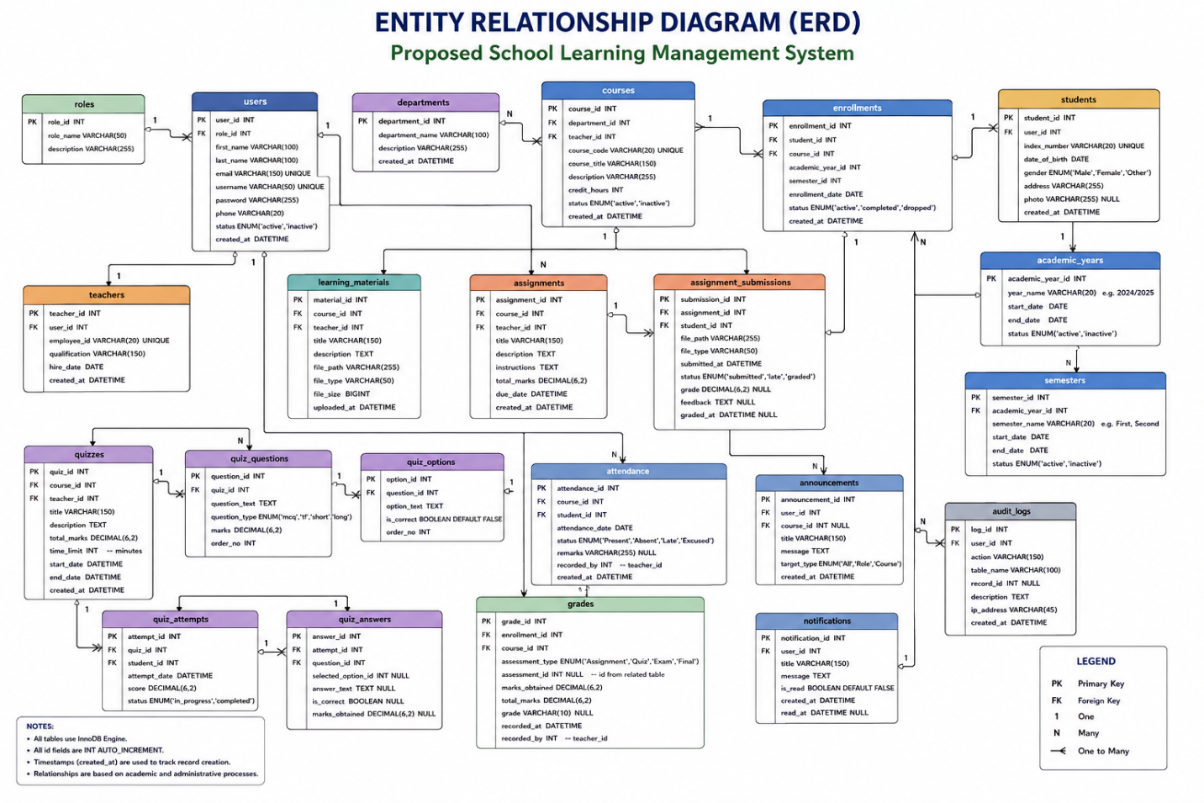

B.2 Major Database Entities
Entity | Purpose
Users | Stores system user information and authentication-related data
Roles | Defines the roles assigned to system users
Institutions | Stores information about participating schools
Students | Stores student-specific information
Teachers | Stores teacher-specific information
Parents | Stores parent or guardian information
Courses | Stores information about academic courses
Course Materials | Stores learning resources associated with courses
Assignments | Stores assignment information
Submissions | Stores student assignment submissions
Quizzes | Stores quiz information
Questions | Stores questions used in quizzes and assessments
Grades | Stores student assessment results
Attendance | Stores student attendance records
Timetables | Stores academic timetable information
Announcements | Stores school and academic announcements
Notifications | Stores system notifications
Messages | Stores communication between authorised users
Audit Logs | Records important system activities

APPENDIX C: API ENDPOINTS
The GSLMS uses a PHP-based Application Programming Interface (API) to facilitate communication between the frontend application and backend services.
C.1 Authentication API
Method | Endpoint | Purpose
POST | /auth/login | Authenticate a user
POST | /auth/logout | End an authenticated session
POST | /auth/refresh | Refresh authentication information
GET | /auth/me | Retrieve authenticated user information

C.2 User Management API
Method | Endpoint | Purpose
GET | /users | Retrieve users
GET | /users/{id} | Retrieve a specific user
POST | /users | Create a user
PUT | /users/{id} | Update a user
DELETE | /users/{id} | Delete a user

C.3 Course Management API
Method | Endpoint | Purpose
GET | /courses | Retrieve courses
GET | /courses/{id} | Retrieve a specific course
POST | /courses | Create a course
PUT | /courses/{id} | Update a course
DELETE | /courses/{id} | Delete a course

C.4 Learning Materials API
Method | Endpoint | Purpose
GET | /materials | Retrieve learning materials
POST | /materials | Upload learning material
PUT | /materials/{id} | Update learning material
DELETE | /materials/{id} | Delete learning material

C.5 Assessment API
Method | Endpoint | Purpose
GET | /assessments | Retrieve assessments
POST | /assessments | Create an assessment
PUT | /assessments/{id} | Update an assessment
DELETE | /assessments/{id} | Delete an assessment

APPENDIX D: SAMPLE API REQUESTS AND RESPONSES
D.1 Login Request
{
"email": "student@example.com",
"password": "********"
}
D.2 Successful Login Response
{
"success": true,
"message": "Login successful",
"data": {
"user": {
"id": 1,
"name": "Student Name",
"role": "student"
},
"token": "JWT_TOKEN"
}
}
D.3 Course Request
{
"name": "Information and Communication Technology",
"code": "ICT101",
"description": "Introduction to ICT"
}
D.4 Example API Response
{
"success": true,
"message": "Course retrieved successfully",
"data": {
"id": 1,
"name": "Information and Communication Technology",
"code": "ICT101"
}
}

APPENDIX E: SYSTEM TEST CASES
E.1 Authentication Testing
Test ID | Test Description | Expected Result | Status
TC-001 | Login with valid credentials | User is authenticated | Pass
TC-002 | Login with invalid password | Error message is displayed | Pass
TC-003 | Login with empty fields | Validation message is displayed | Pass
TC-004 | Logout | User session is terminated | Pass

E.2 User Management Testing
Test ID | Test Description | Expected Result | Status
TC-005 | Create user | User account is created | Pass
TC-006 | Update user | User information is updated | Pass
TC-007 | Delete user | User is removed/deactivated | Pass
TC-008 | Retrieve user | Correct user information is displayed | Pass

E.3 Course Testing
Test ID | Test Description | Expected Result | Status
TC-009 | Create course | Course is created | Pass
TC-010 | Update course | Course information is updated | Pass
TC-011 | View course | Course information is displayed | Pass
TC-012 | Delete course | Course is removed | Pass

E.4 Assessment Testing
Test ID | Test Description | Expected Result | Status
TC-013 | Create assessment | Assessment is created | Pass
TC-014 | Submit assessment | Submission is recorded | Pass
TC-015 | Record grade | Grade is stored successfully | Pass
TC-016 | View grade | Correct grade is displayed | Pass

APPENDIX F: USER MANUAL
F.1 Student User Guide
Step 1: Login
The student opens the GSLMS login page and enters the registered username/email and password.
Step 2: Access Dashboard
After successful authentication, the student is redirected to the Student Dashboard.
Step 3: Access Courses
The student selects the Courses section to view registered courses.
Step 4: Access Learning Materials
The student selects a course and accesses the available learning materials.
Step 5: Complete Assignments
The student opens an available assignment, reviews the instructions, completes the required work, and submits it through the system.
Step 6: Take Quizzes
The student selects an available quiz and completes it within the specified conditions.
Step 7: View Grades
The student can access available academic results through the grades section.
Step 8: View Attendance
The student can review attendance information recorded by authorised teachers.
APPENDIX G: TEACHER USER GUIDE
Teachers can perform the following activities:
- Log into the system.
- Access the Teacher Dashboard.
- Manage assigned courses.
- Upload learning materials.
- Create assignments.
- Review student submissions.
- Create quizzes.
- Manage assessment questions.
- Record or review grades.
- Record student attendance.
- View relevant reports.
- Communicate with students and other authorised users.
- Publish relevant announcements.
APPENDIX H: ADMINISTRATOR USER GUIDE
Administrators can:
- Log into the administrative dashboard.
- Manage students.
- Manage teachers.
- Manage parents or guardians.
- Manage courses.
- Manage academic years and semesters.
- Manage institutional information.
- Monitor academic activities.
- Manage announcements.
- View reports and analytics.
- Monitor system activities.
- Manage authorised users and permissions.
APPENDIX I: SYSTEM INSTALLATION GUIDE
I.1 Software Requirements
The system requires an appropriate web-server environment capable of running PHP and MySQL.
Recommended components include:
- PHP
- MySQL
- Apache or Nginx
- Web browser
- Composer
- Git
I.2 Backend Installation
- Clone the project repository.
- Navigate to the backend directory.
- Install the required PHP dependencies.
- Configure the environment variables.
- Create the required MySQL database.
- Import the database schema.
- Configure the web server.
- Start the backend API.
- Test the API endpoints.
I.3 Frontend Installation
- Navigate to the frontend directory.
- Configure the API base URL.
- Ensure the frontend can communicate with the PHP API.
- Open the application through the configured web server.
- Test user authentication and system functionality.
Security note: Production installations should use secure environment variables and should not expose database passwords, JWT secrets, API credentials, or other sensitive configuration values.
APPENDIX J: PROJECT REPOSITORY STRUCTURE
The project is maintained using Git version control.
The major project components include:
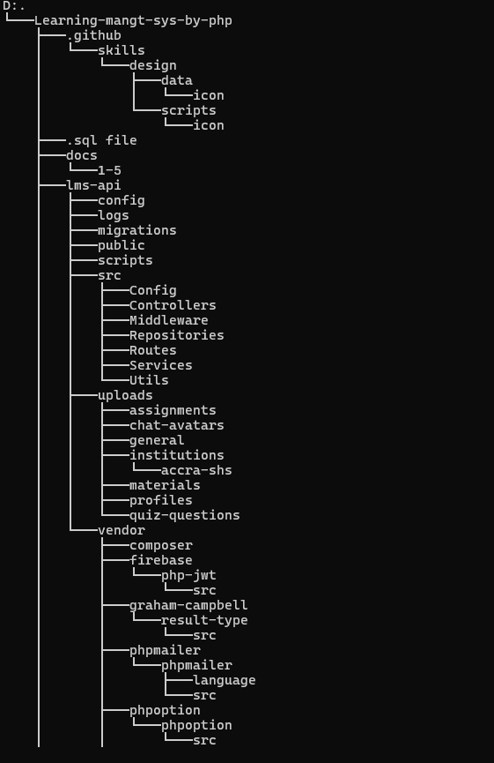
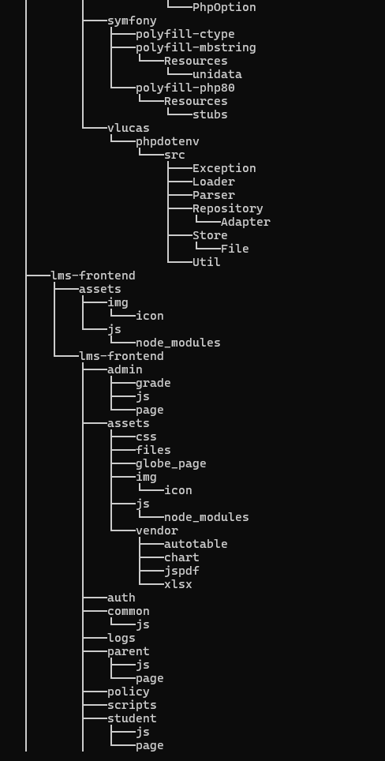
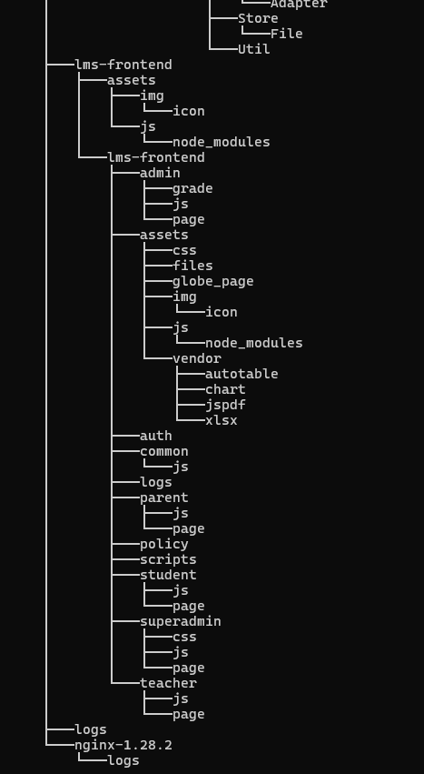
The backend provides API services while the frontend provides the user-facing interfaces.

APPENDIX K: SAMPLE DATABASE OPERATIONS
K.1 Create a Course
INSERT INTO courses
(name, code, description)
VALUES
('Information and Communication Technology',
'ICT101',
'Introduction to ICT');
K.2 Retrieve Courses
SELECT *
FROM courses
ORDER BY name ASC;
K.3 Retrieve Student Grades
SELECT *
FROM grades
WHERE student_id = ?;
K.4 Retrieve Attendance Records
SELECT *
FROM attendance
WHERE student_id = ?;
APPENDIX L: SECURITY CONSIDERATIONS
The system incorporates security mechanisms intended to protect users and academic information.
Key security considerations include:
- User authentication.
- Role-based access control.
- JWT-based authentication.
- Password protection.
- Input validation.
- API authorisation.
- Session management.
- Database access controls.
- Audit logging.
- Protection against unauthorised access.
Sensitive configuration information should be stored outside publicly accessible source files and should not be committed to the public repository.
APPENDIX M: PROJECT GANTT CHART
Table M.1: Project Implementation Schedule
Activity | Phase 1 | Phase 2 | Phase 3 | Phase 4 | Phase 5
Requirement gathering | ✓
Literature review | ✓ | ✓
System analysis |  | ✓
System design |  | ✓ | ✓
Database development |  |  | ✓
Backend development |  |  | ✓ | ✓
Frontend development |  |  | ✓ | ✓
System integration |  |  |  | ✓
Testing |  |  |  | ✓ | ✓
Documentation | ✓ | ✓ | ✓ | ✓ | ✓
Final evaluation |  |  |  |  | ✓

APPENDIX N: PROJECT TEAM
The project was developed by:
BENEDICT OSEI AMANKWA
AND
BOATENG NKANSAH ALVIN
Project Title
DESIGN AND IMPLEMENTATION OF A GHANA SENIOR HIGH SCHOOL LEARNING MANAGEMENT SYSTEM (GSLMS)
The project focuses on the design and implementation of a web-based platform for supporting teaching, learning, assessment, academic administration, communication, and monitoring within Senior High Schools in Ghana.

